Florida Department of Corrections
INITIAL REPORTING INSTRUCTIONS
Hillsborough County Criminal Divisions: W/Y - Judge Elizabeth G. Rice

Name: _________________________________ DC Number: _____________ Date: ________________

Case #(s):_______________________ Charge(s):______________________________________________

Supervision Type:

Drug Offender Probation Drug Pre-Trial Intervention (DPTI)/transfer to Division W Probation

You are instructed to report immediately to the Department of Corrections office as follows:

In person - 1313 North Tampa Street, Suite 124, Tampa, FL 33602 at 9:00am tomorrow
(or by 4:00 p.m. the next business day after release from custody)

In person - Suite 348, Hillsborough County Court Building (3rd Floor Annex)

Report to your Probation Officer: In person by phone

Make contact with PTI staff at the PTI office by calling (813) 975-6524 8am-4:30pm tomorrow
(or by 4:00 p.m. the next business day after release from custody)

*Failure to report as instructed is a violation of the terms of supervision, as provided in Section 948.03 Florida Statutes.*

Contact Information:

Tampa Intake Office location: 1313 N. Tampa Street Suite #124, Tampa, FL 33602
Telephone Number: 813-233-3450

Courthouse location: Suite 348 is located next to Courtroom 33 on the 3rd floor of the Courthouse Annex.

Tampa PTI Office: Contact by phone at (813) 975-6524

Entrance into the Park Trammell building requires photo identification. This document will allow you into the building for your first visit only if you do not have identification. Be sure to obtain ID before your return visit. 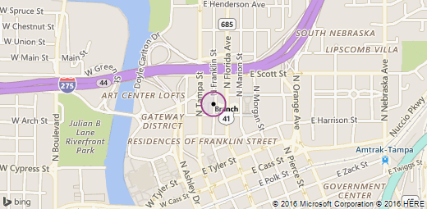
Revised 06/14/2021
RH/KGH/EGR

